Product Perspective
SlashNews is a stand-alone web-based application developed as part of a Software Design Patterns course project. The system is not intended to integrate with external commercial platforms but is designed as an independent and self-contained content aggregation platform. It demonstrates the practical application of software design principles within a controlled academic environment.
The software follows a modular and configurable architecture, allowing future integration with other systems if required. However, within the scope of this project, SlashNews operates as an independent system with its own backend logic, database, and user interaction mechanisms.

Product Functions
SlashNews will provide a web-based platform where users can submit, browse, and interact with content. The system will display ranked content feeds based on configurable ranking strategies (e.g., top or new). Users will be able to view individual posts, participate in threaded discussions, and interact through upvoting and commenting.
The system will also support basic user role management, including moderator capabilities such as removing inappropriate posts or comments. Additionally, the application will include a structured backend architecture that ensures modularity, configurability, and maintainability through the use of software design patterns.

User Characteristics
SlashNews is designed for general users who have basic experience with web applications. Standard users are expected to have fundamental internet navigation skills, such as browsing content, submitting forms, and interacting with posts through voting and commenting. No advanced technical knowledge is required for regular platform usage.
The system also includes moderator users, who are expected to have a slightly higher level of familiarity with the platform’s structure and content management features. Moderators should understand basic content management principles but do not require technical or programming expertise.
From a development perspective, contributors or maintainers of the open-source project are expected to have intermediate programming knowledge and familiarity with software design principles.

Constraints
The project is developed within the constraints of an academic course timeline and must be completed within the specified semester schedule. The system will be implemented using selected programming languages and frameworks agreed upon by the team, and development will be limited to commonly available open-source tools and local development environments.
The application will operate as a web-based platform and will not include mobile application development. Additionally, due to time and resource limitations, the project will not address large-scale deployment, high-performance optimization, or production-level security requirements.

System Features (Use Case Based)

Use Case 1:
Title: Browse Ranked Feed
Main Actor: User
Goal: View a ranked list of posts (e.g., Top, New).
Preconditions:
- The system is running.
- Posts exist in the database.

Main Flow:
- The user accesses the main page.
- The user selects a feed type (if applicable).
- The system retrieves posts using the selected ranking strategy.
- The system displays the ranked feed.

Postconditions:
- The user can view and select posts from the feed.

Use Case 2:
Title: View Post and Comments
Main Actor: User
Goal: View a selected post and its threaded comments.
Preconditions:
- The selected post exists.

Main Flow:
- The user selects a post from the feed.
- The system retrieves post details.
- The system retrieves associated comments.
- The system displays the post and comment thread.
Postconditions:
- The user can read the post and its comments.

Use Case 3:
Title: Submit Post
Main Actor: User
Goal: Submit a new post (link or text).
Preconditions:
- The user is authenticated (if authentication is implemented).
Main Flow:
- The user opens the submission form.
- The user enters post details (title and content/link).
- The system validates the input.
- The system saves the post to the database.
- The system confirms successful submission.
Postconditions:
- The new post appears in the appropriate feed.

Use Case 4:
Title: Add Comment
Main Actor: User
Goal: Add a comment to a post.
Preconditions:
- The selected post exists.

Main Flow:
- The user enters comment text.
- The system validates the input.
- The system stores the comment in the database.
- The system updates the comment thread.

Postconditions:
- The comment becomes visible under the post.

Use Case 5:
Title: Vote Content
Main Actor: User
Goal: Increase or decrease the score of a post or comment.
Preconditions:
- The content exists.
- The user has not already voted (if voting restrictions apply).

Main Flow:
- The user selects the upvote option.
- The system validates the voting action.
- The system records the vote.
- The system updates the score and ranking if necessary.

Postconditions:
- The content score increases and ranking may change accordingly.

Use Case 6:
Title: Moderate Content
Main Actor: Moderator
Goal: Remove or hide inappropriate posts or comments.
Preconditions:
- The moderator is authenticated.
- The moderator has authorization privileges.

Main Flow:
- The moderator selects content to moderate.
- The system verifies moderator privileges.
- The system removes or hides the selected content.
- The system confirms the moderation action.

Postconditions:
- The moderated content is no longer visible to regular users.

Use Case 7:
Title: Use Voice Reading Support
Main Actor: User (including users with visual impairments)
Goal: Listen to post content and comments through voice reading support.

Preconditions:
- The selected post exists.
- Voice reading support is enabled in the system.

Main Flow:
- The user opens a post detail page.
- The user selects the “Read Aloud” or voice support option.
- The system converts the post content (and optionally comments) into audio output.
- The system plays the generated audio through the user’s device.
- The user may pause or stop the audio playback.

Postconditions:
- The user is able to access the content through audio output.
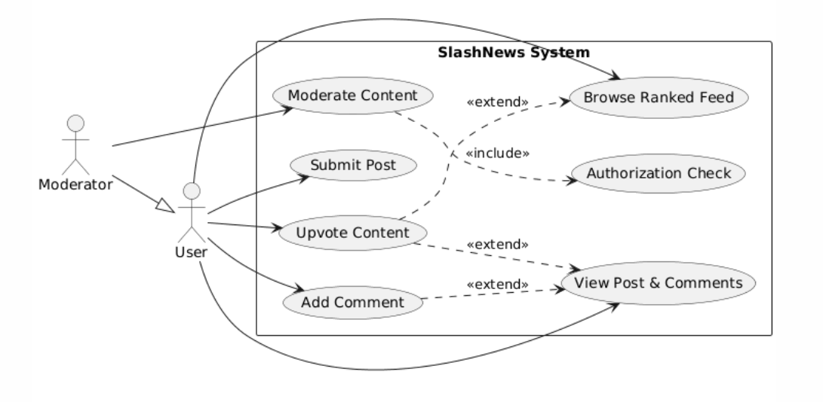
Use Case Diagram

Non-Functional Requirements

Usability
The system should be easy to use for individuals with basic web browsing experience. Users should be able to navigate feeds, view posts, vote, and comment without requiring technical knowledge. The interface should be clear, consistent, and accessible, following basic usability and accessibility principles.

Performance
The system should respond to user actions (such as loading feeds, opening posts, or submitting votes) within an acceptable time under normal usage conditions. Page load and interaction responses should occur within a few seconds during testing. Large-scale performance optimization is not required, as the system is developed for academic purposes.

Portability

SlashNews should operate as a web-based application accessible through modern web browsers. The system should run on standard desktop operating systems without requiring specialized hardware or software beyond common development tools.

Reliability
The system should operate consistently during normal usage and avoid crashes or critical errors. Core functionalities such as browsing, voting, commenting, and moderation should function reliably during testing. Proper error handling should be implemented to manage invalid inputs or unexpected system behavior.

User Interfaces
SlashNews provides a web-based user interface accessible through a standard browser. The major screens and interactions of the system include:
- Home / Feed Page
Displays a ranked list of posts (e.g., Top, New). Users can navigate between feed types and select individual posts.
- Post Detail Page
Shows the selected post along with its full content and threaded comments. Users can read discussions, upvote content, and add comments.
- Post Submission Page
Allows users to submit new posts by entering a title and either a link or text content.
- Moderation Interface
Provides moderators with the ability to remove or hide inappropriate posts and comments.
- Navigation Components
Includes basic navigation elements such as feed selection, submission links, and user-related actions.
The interface will prioritize simplicity, clarity, and accessibility, ensuring that users can easily navigate and interact with the system without requiring advanced technical knowledge.

Software Interfaces
SlashNews interacts with several supporting software components to provide authentication and security features.
The system integrates with an email service provider to send account-related notifications such as verification emails and two-factor authentication (2FA) codes. This interaction occurs through a standard email API or SMTP service.
For enhanced security, the system supports Two-Factor Authentication (2FA), which may involve generating and validating one-time passwords (OTP). This functionality can rely on a standard OTP library compliant with common authentication standards.
Additionally, SlashNews supports Passkey-based authentication, utilizing modern WebAuthn standards. This allows interaction with browser-supported authentication mechanisms and device-level credential management systems. The system communicates with browser APIs that implement WebAuthn protocols but does not directly manage external authentication servers.
All external integrations are limited to authentication and notification purposes. No third-party content providers or commercial data services are integrated into the system.

